

**UNIVERSITY OF NAIROBI**

**SCHOOL OF COMPUTING AND INFORMATICS**

**ARV DRUGS ISSUANCE TRACKER AND DIET DECISION SUPPORT SYSTEM FOR PEOPLE LIVING WITH HIV/AIDS**

**NAME:** KARANJA DENIS MBURU

**ADM. NO:** P15/55431/2012

**SUPERVISOR:** DR. CHRISTOPHER CHEPKEN

**YEAR:** 2015/2016

# 1: INTRODUCTION

## 1.1 Background

ARV drugs issuance in Kenyan Health centers has proved to be one of the most controversial services in the sense that, health officers in charge do not keep a clear and actual record of the Anti-Retroviral (ARV) drugs being issued to people living with HIV/AIDS (PLWHA).

Most of these drugs get ferried to private pharmacies where they get sold to persons who have the ability to purchase them. This affects the less privileged HIV positive persons since they cannot afford to purchase the drugs from the private pharmacies.

This evil practice by these unscrupulous health officers is normally aided by the lack of an efficient working system that can keep records and account for the number of ARV drugs issued to HIV positive persons.

Lack of proper ARV drugs medications record keeping has lead to miss-use of ARVs i.e. ARVs being put into the wrong use e.g. illicit brewing which has been a major cause of deaths in Kenya. This has lead into having ARV drugs deficit in health centers.

## 1.2 Problem Statement

## Paper work is the current way of keeping ARV drugs issuance records which cannot be relied on since tracking a patient becomes a problem especially if a patient decides to have drugs issued in a different facility altogether.

## Patients are abusing this free ARV drugs privilege by putting the drugs into illegal use, selling them to business people who then practice illicit brewing which is very costly for the government as well as the overall human health.

## Human health has been put at risk especially when a genuine drug needing HIV patient comes for drugs only to find the health center out of stock simply because these drugs were issued to the “wrong” person. Wrong in the sense that they may already have had their drugs from a different facility but still go on to other facilities to get issued with the same drugs but this time for business purpose.

## “Tiba Bora System”, will see the end of these mischief by offering a network HIV module patient data to all facilities with an up to date record of all the ARV drugs issued from each facility, to whom they were issued, when and the center that issued them.

Patients will be able to keep track of their due dates through system generated messaged that will be sent to patient’s mobile phones as a reminder and also advice on the facility that most likely will have these drugs before the due date based on certain parameters. Patients will also benefit from well learned advice on what diet to take on so that they can improve on their current CD4 cell count. CD4 cell count is a major indicator of how well your immune system is working and it is the strongest predictor of HIV progression.

## 1.3 Objectives

### 1.3.1 System objectives

* To provide a network platform where mandated health officers can search for HIV/AIDS patient details, register a patient if they don’t exist in the network.
* To provide a manage area for all facilities in the network from which reliable reports can be generated and sent to the government to help in planning and facilitation.
* To provide diet guidance to the patients through studying each patient’s CD4 cell count
* To ensure confidentiality and patient data security
* To provide a patient profile portal where a registered patient can

### 1.3.2 Research objectives

* To gather data on how ARV drugs are administered to patients.
* To know measure taken to ensure confidentiality and patient data privacy.
* patient medical history on ARVs.
* To gather information about how patient reach out is done.
* To know the circumstances under which patients can be re-issued ARVs.
* To know various measures taken in ensuring that patient CD4 cell count for patients is improved or maintained.

## 1.4 Justification

Currently, Electronic Medical Record systems (EMR) have been known to keep track of all the drugs issued in a facility. ARV drugs are sensitive and tracking them should be done exclusively.

This application will see the end of scenarios where health officers cannot fully account on ARV drugs issued to the patients. Health officers will be able to account for the total number of ARV drugs administered to patients.

“Tiba Bora” will have an Application Programming Interface (API) which will help provide reliable data to the health centers in the network which will help generate reliable reports and guide through business intelligence.

HIV/AIDS patients will be able to get diet guidance based on their CD4 cell count. This diet guidance will be auto-generated by the system based on some metrics and rules that will be stored in a knowledge base.

The government will also have a clear account of the drugs in use by all facilities on request through electronic mail which will help average the number of drugs needed during a certain duration which will help the government in planning.

# 2: LITERATURE REVIEW

***Tiba Bora*** system will be the first ***stand*** ***alone*** system in Kenyan health industry and will be of great help to health workers, the government and mainly to the patients.

The government will be able to give an exact account of the number of ARV drugs administered to patients in each facility. This will greatly facilitate in government planning.

A case study dubbed “Sisters of Death” done by a local media house on 12th April, 2012 elaborates how illicit brew is made from ARVs and how unhygienic it is done (see<http://goo.gl/Szk2Fc)>. Illicit brew in Kenya has been A major cause of deaths in Kenya and this system will ensure that no ARVs find their way out which will reduce illicit brewing through ARV drugs.

Health officers will be able to:

* Search for patients in the network using their national Identification.
* Register new patients if they don’t exist in the network
* Administer ARV drugs to patients on a click of a button

Facility coordinator will be able to:

* Search for patients in the system using National ID
* View reports of the total number of HIV positive patients in their respective facility.
* View a report report on the total number of ARV drugs issued on Weekly, Monthly and Semi-annual

Patients will be able to:

* Receive current medication due dates through SMS
* Receive diet advice based on their CD4 cell count
* See their medication history

# 3: METHODOLOGY

## 3.1 Methodology

The model of development adopted in this system is the prototyping development methodology. The Prototyping Model is a systems development method (SDM) in which a prototype (an early approximation of a final system or product) is built, tested, and then reworked as necessary until an acceptable prototype is finally achieved from which the complete system or product can now be developed. This methodology is suitable for this project since some of the project requirements are not known in detail ahead of time. Also, there will be iterations and trial-and-error processes between the user and the developers.

## 3.2 Approach

Based on the Prototyping Methodology paradigm, the project will be carried out in a sequence of analysis, design phases and documentation. Activities to be carried out at each stage include:

### 3.2.1 Requirements specification and analysis

This stage involves the acquisition of data relevant to the development of the system and its subsequent analysis to provide information for the design phase. It also involves the resolution of such issues as the feasibility of the project in terms of its economic, technological, technical, time and schedule areas of concern. The deployment of such techniques as interviews, discussions, observation and prototyping will facilitate the acquisition of information relevant to the development of a logical design that clearly shows the functionalities of the system. Analysis of the acquired data involves the development of relevant graphical models that explain the systems functionality and its interaction with the users. Such diagrams as Data Flow Diagrams and Entity Relationship Diagrams are expected at the end of this phase.

**3.2.2 Design**

This phase of system development involves the creation of a high level architectural structure of the solution in terms of software components, databases, User Interface and operating environment. It comprises the following:

* Specifying programs
* Selecting appropriate equipment
* Specifying Databases
* Detailed procedures

**3.2.3 Implementation and coding**

This stage involves the translation of the developed designs into an actual system using suitable programming languages. Given it is an online based web application, the system will be developed through the use of HTML5, Python (Django and Django REST Framework), PostgreSQL, JavaScript (Angular Framework) and CSS3 so as to achieve the defined functionalities and user interface requirements. At the end of this stage, a physical system that can be used and tested will be developed.

Third party applications that ensure continuous integration will be used. The preferred one is Circle CI (<https://circleci.com/>).

**3.2.4 Testing, Evaluation and Improvements**

Testing will be an inherent part of every stage in development. There will be validation and verification of the deliverables at every stage to determine whether they have been satisfied. Test plans against which the system will be tested will be developed during the requirement engineering stage. For the modules and the final application, the metrics that will be tested here mainly will be validity, correctness, performance and scalability.

***Advantages***

* *Reduce time and costs:* Prototyping can improve the quality of requirements and specifications provided to developers. Changes, costs exponentially more to implement especially when they are detected later in the development. Early determination of what the user really wants can result in faster development as well as reduced development costs.
* Users are actively involved in the project
* Users get a better understanding of the system being developed

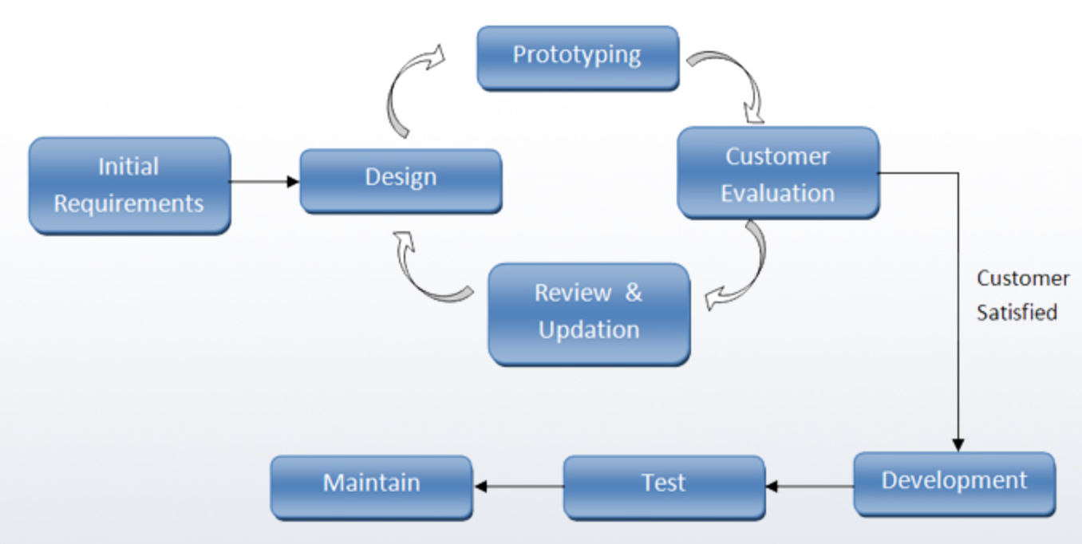

# 4 RESOURCES

The development of this web application will various hardware, software and resources as listed below:

## 4.1 Hardware equipment

* Computer (with at least 1GB ram, 2 GHZ, 20gb hard disk)

## 4.2 Software Requirements

* Sublime Text Editor.
* Circle Continuous Integration (CI)
* GIT (Version Control System)
* Google Chrome and Mozilla Firefox browser
* Gantt chart for project management
* Unix Operating System (For development and deployment)
* JavaScript (AngularJS), CSS3, HTML5, Python (Django and Django REST Framework)

## 4.3 Services

* Internet connection.

## 4.4 Choice of programming tools

* *HTML 5, CSS3, JavaScript(AngularJS)* – These are the languages used for creating user interfaces for web applications.
* *Python Django* - A High-level Python Web framework that encourages rapid development and clean, pragmatic design. (Open Source)
* *Django REST Framework (D.R.F)* - A powerful and flexible toolkit that makes it easy to build Web APIs. (Open Source)
* *Circle CI* – A powerful Open source tool that gives developers a state-of-the-art automated testing and continuous integrations tools.
* *GIT* -A widely used version control system for software development. It is a distributed revision control system with an emphasis on speed, data integrity, and support for distributed, non-linear workflows. (Open Source)

# 5 PROJECT WORK PLAN

The following timeline shall be observed in the implementation of this proposed project.

## 5.1 Project activity plan

|  |  |  |  |
| --- | --- | --- | --- |
| **#** | **ACTIVITY** | **DURATION (WEEKS)** | **DATES** |
| **1** | Research and literature analysis | 3 | 14th Sep 2015 – 5th Oct 2015 |
| **2** | Project Proposal | 2 | 6th Oct 2015 – 20th Oct 2015 |
| **3** | Requirement specification, data collection and analysis | 2 | 22nd Oct – 6th Nov 2015 |
| **4** | System Design (Sketches, ERDs, DFDs and Use cases) | 2 | 7th Nov 2015 – 21st Nov 2015 |
| **5** | Implementation and Development | 13 | 23rd Nov 2015 – 14th Feb 2016 |
| **6** | Testing and Improvement | 3 | 15th Feb 2016 – 4th Mar 2016 |
| **7** | Documentation, User manuals and Technical guide | 2 | 14th Sep 2015 – 20th Mar 2016 |

## 5.2 Gantt chart for Project Timeline

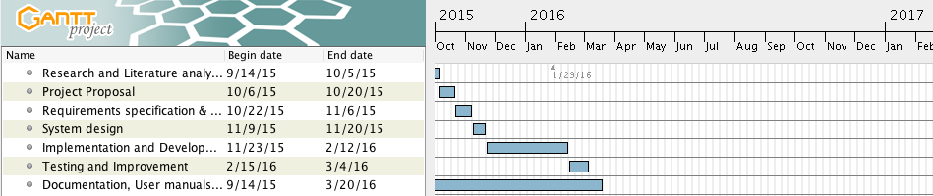

# 6 REFERENCES